**Jenkins Installation Documentation**

**What is Jenkins:**

Jenkins is an open source [continuous integration](https://www.techtarget.com/searchsoftwarequality/definition/continuous-integration)/continuous delivery and deployment (CI/CD) automation software DevOps tool written in the [Java](https://www.theserverside.com/definition/Java) programming language. It is used to implement CI/CD workflows, called pipelines.

Prerequesites:

## AWS EC2- Instance(Windows)

## Minimum hardware requirements: 256 MB of RAM,1 GB of drive space

## Java 11 0r 17

Web-browser

**Launch EC2-Instance(Windows):**

Launch EC2 -Instance for windows

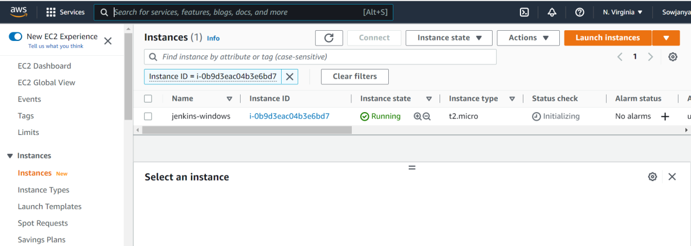

**Connect to instance:**

On the **Connect to instance** page, choose the **RDP client** tab, and then choose **Get password**.

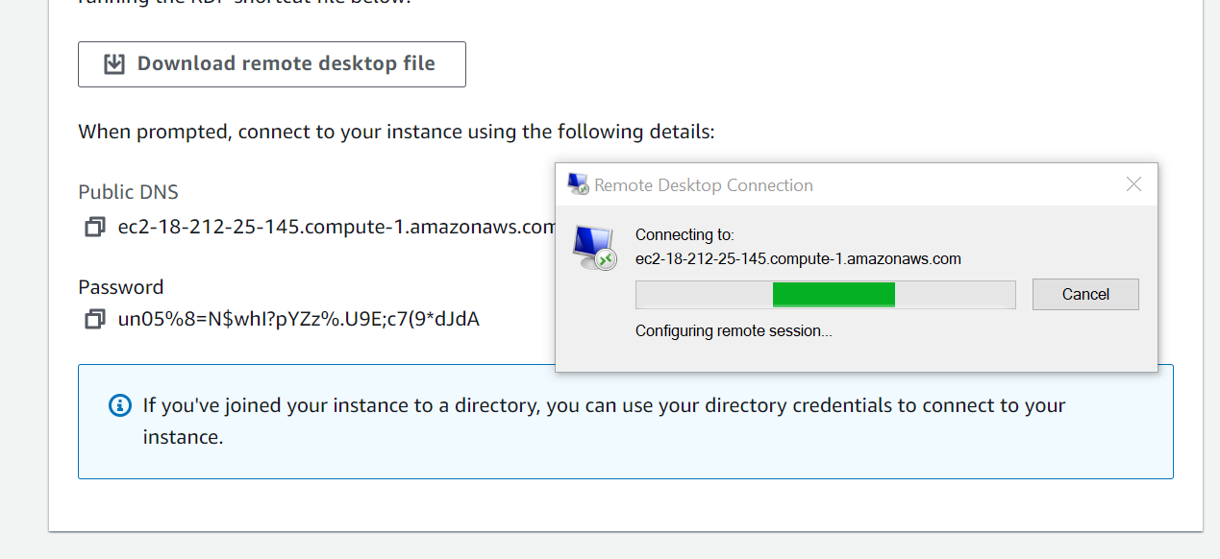

**Configure security group:**

Allow internet traffic to reach instance, add rules that allow unrestricted access to the **HTTP** and **HTTPS** ports.

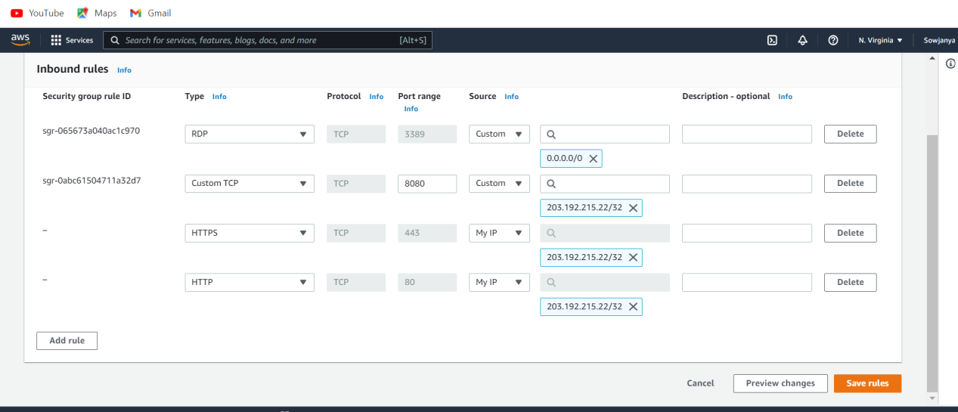

### **Installing JAVA 11:**

Downloading the **JDK** Installer. Access Java SE Downloads page and click Accept License Agreement. Running the JDK Installer.

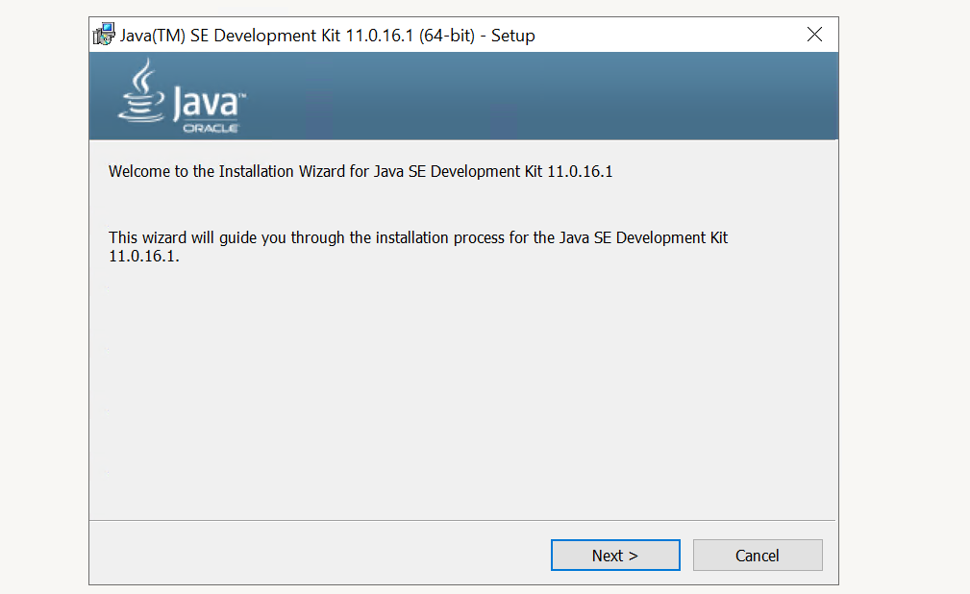

**Set JAVA_HOME and PATH Environment**

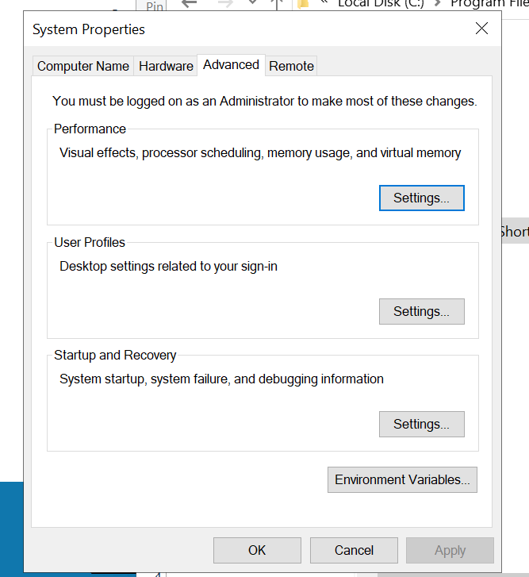

Variables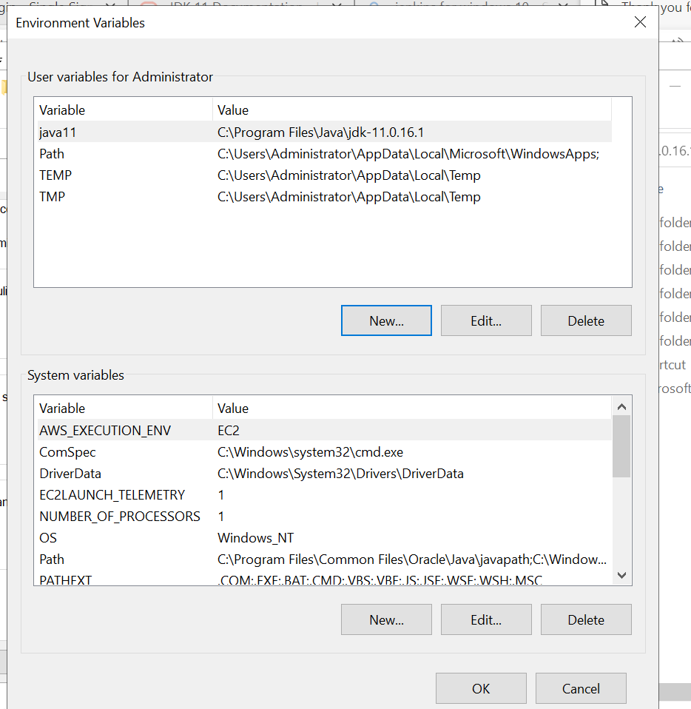

Checking whether java version is installed or not in terminal using command “java -version”

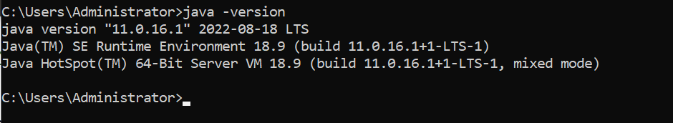

**Install Jenkins:**

Search from browser

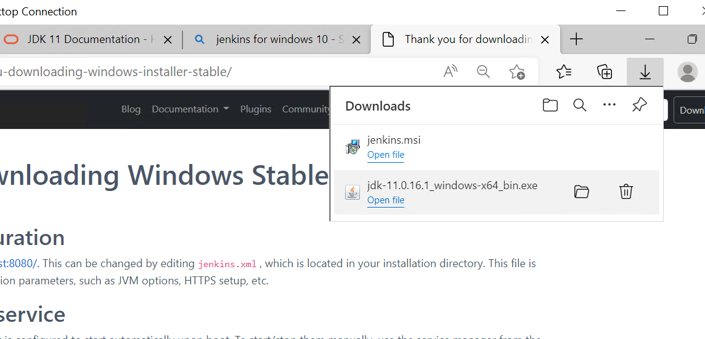

**Setup wizard:**

On opening the Windows Installer, an ****Installation Setup Wizard**** appears, Click ****Next**** on the Setup Wizard to start your installation.Select the destination folder to store your Jenkins Installation and click ****Next**** to continue.

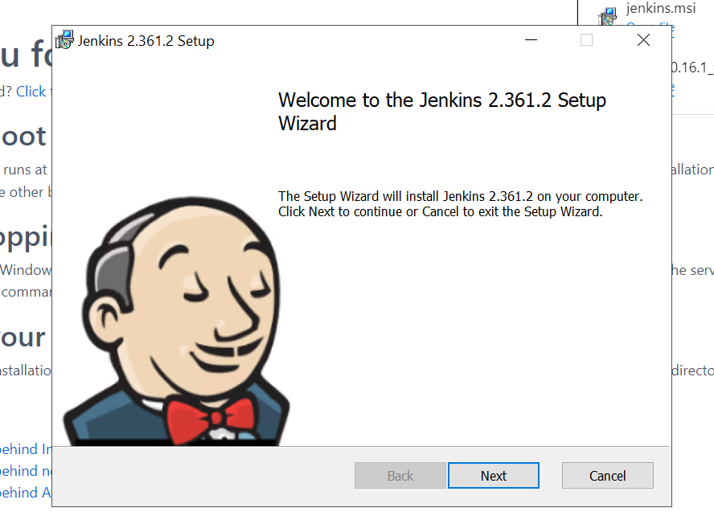

**Service logon credentials:**

to run Jenkins service using a ****local or domain user****, specify the domain user name and password with which you want to run Jenkins, click on ****Test Credentials**** to test your domain credentials and click on ****Next****.

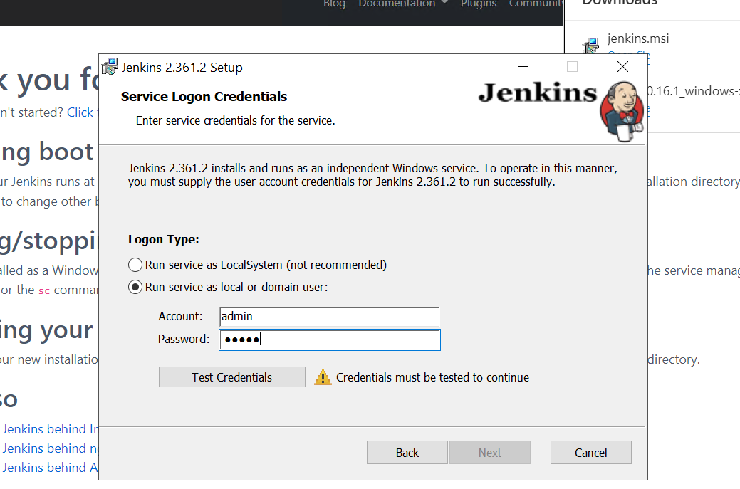

**Port selection:**

Specify the port on which Jenkins will be running, then click on ****Next****.

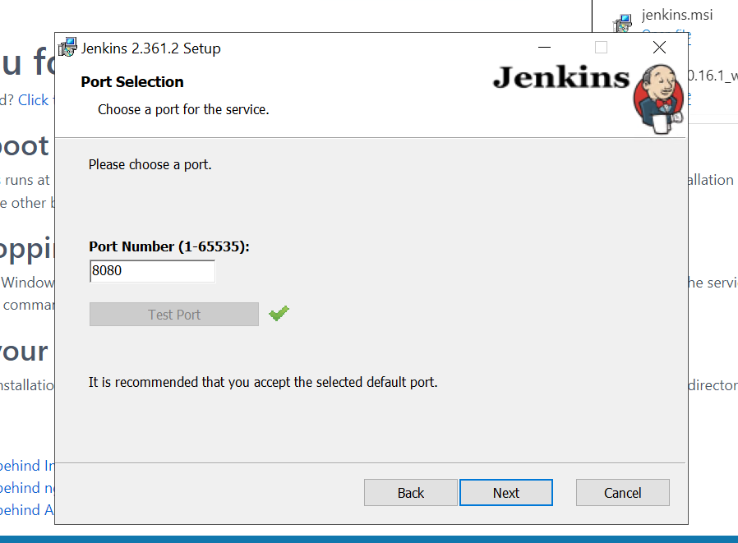

**Select Java home directory**

Once your Java home directory has been selected, click on ****Next**** to continue.

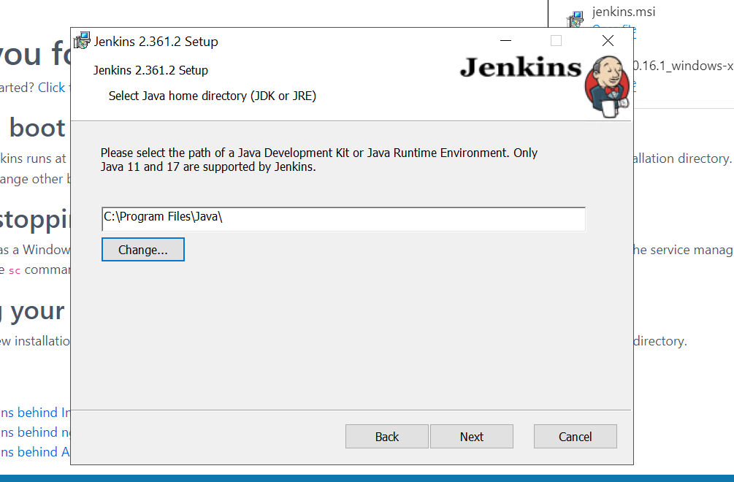

**Finish Jenkins installation:**

Completed jenkins installation

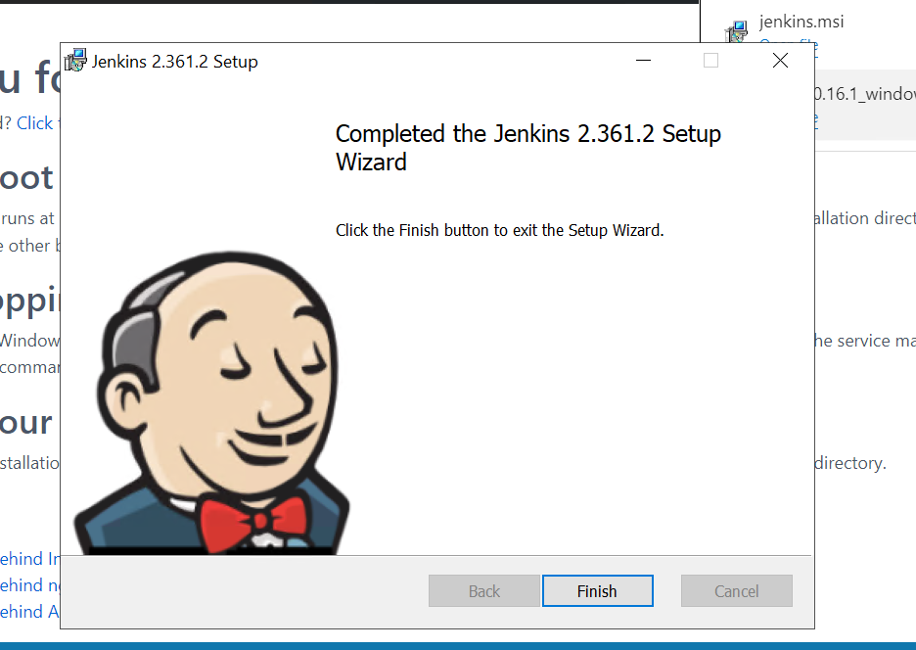

### Unlocking Jenkins

**Step 1:**

Browse to http://localhost:8080  and wait until the ****Unlock Jenkins**** page appears.

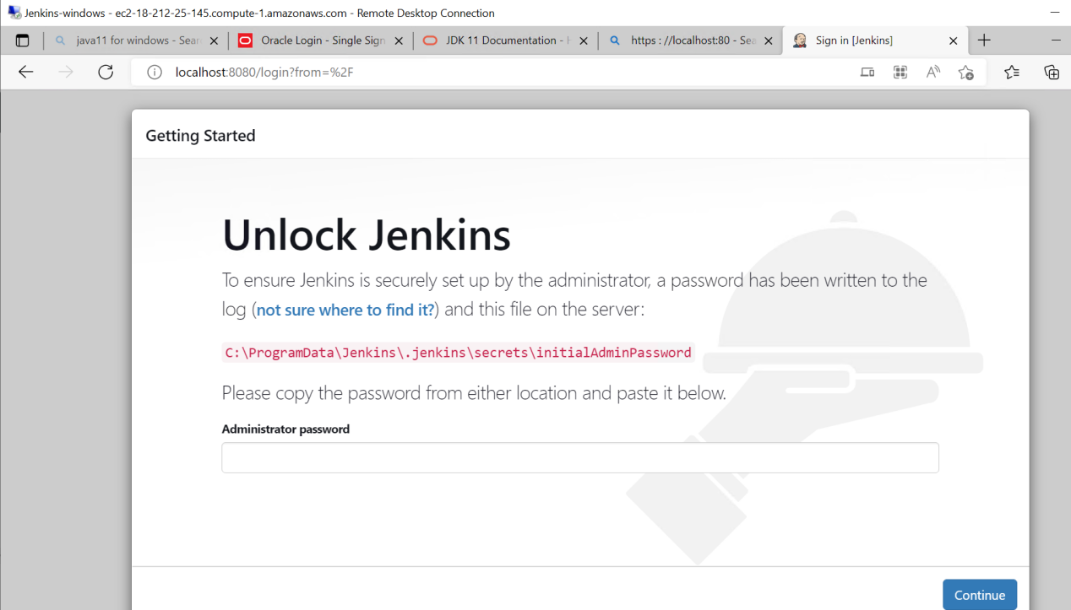

**STEP 2:**

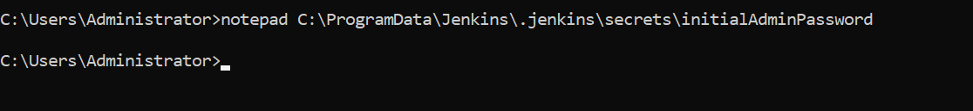

**STEP 3:**

Open the highlighted file and copy the content of the ****initialAdminPassword**** file.

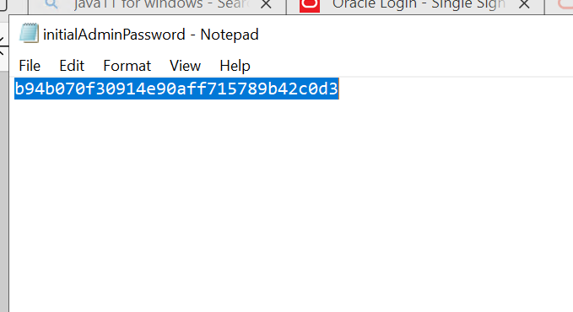

**STEP 4:**

On the ****Unlock Jenkins**** page, paste this password into the ****Administrator password**** field and click ****Continue****.

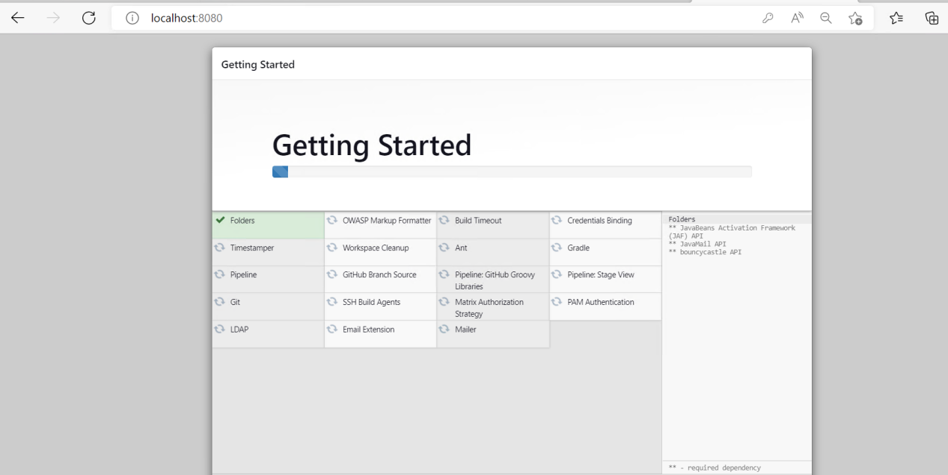

**STEP 5:**

Setup new credentials for jenkins user and click on save and continue

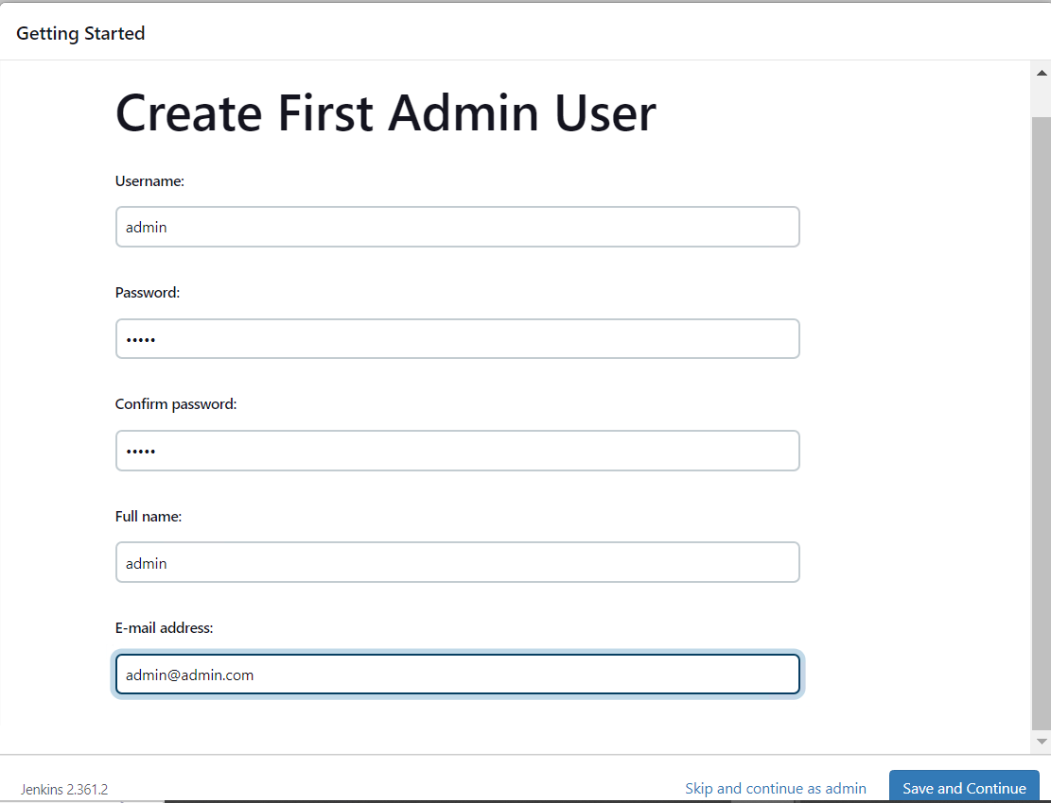

**STEP 6:**

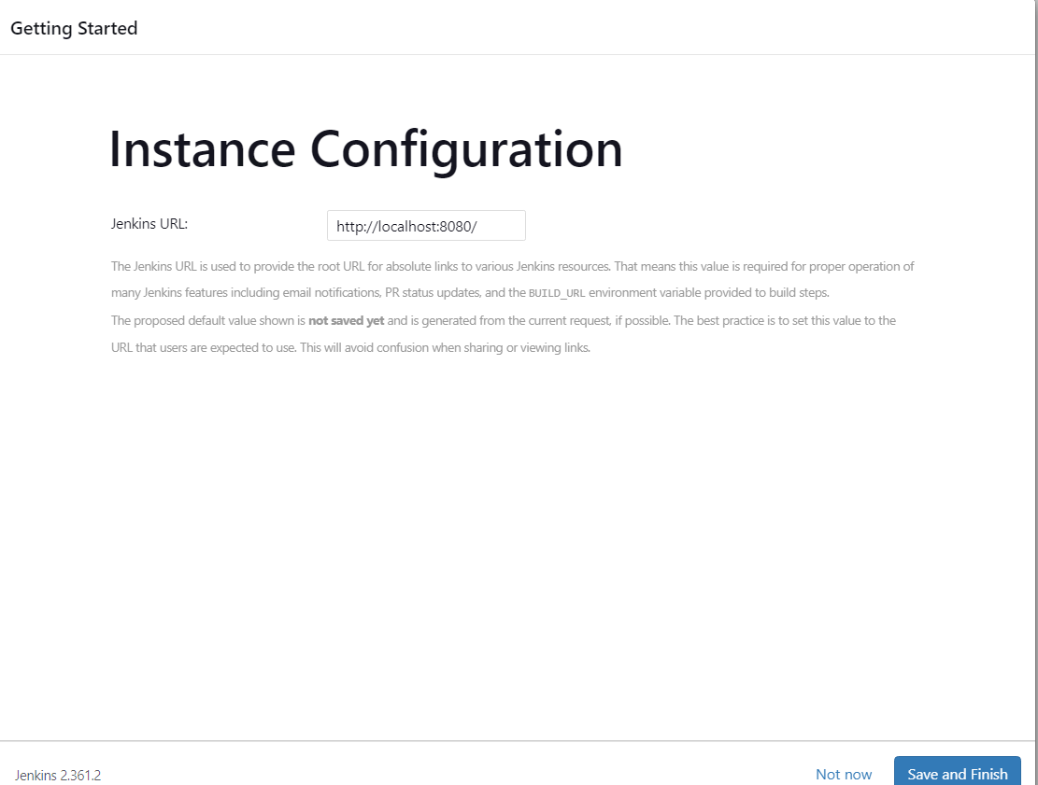

**STEP 7:**

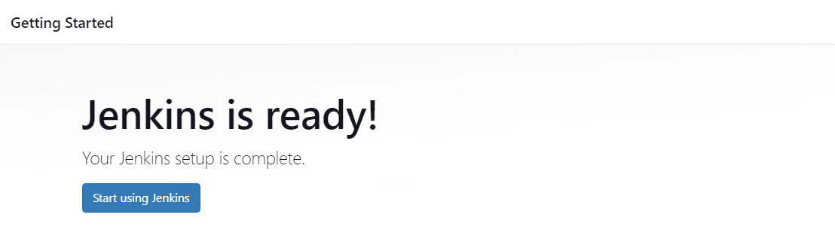

**STEP 8:**

Finally this is the jenkins dashboard

